Curriculum vitae

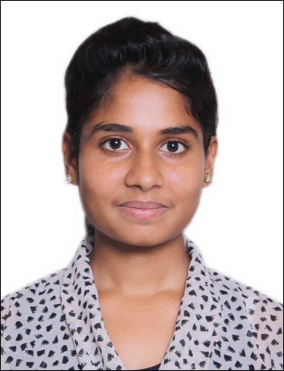 Nikita HOUSENO-202, Rampuri, Roorkeeroad, MUZAFFARNAGAR (U.P)
EMAIL-nikitapadma1999@gmail.com

PHONE N0-9719795893

Seeking for an opportunity in an organization as an intern where I can utilize my skills and enhance knowledge.

ACADEMIA

- Pursuing B. Tech. (Computer Science) from S.D College of Engineering and Technologies, Muzaffarnagar (A.K.T.U) with 72% Aggregate (till 6th semester) and will complete my degree since 2020.
- Higher secondary 12th from U.P. Board in 2016 with 80% marks.
- Secondary 10th from U.P. Board in 2014 with 80% marks.

TECHNICAL SKILLS

- Languages : C, Python, Django

- Operating Systems : Microsoft Windows Operating System .
- Database : Oracle 11g

INDUSTRIAL VISIT

- MCN Solutions , Noida

AREA OF EXPERTISE

- Expertise in problem solving.
- Web Control management

INTERESTING SUBJECTS

- Data Structure
- Database management System
- Software Engineering
- Software project management

PERSONALITY TRAITS

- Easily gets adapted to work places.
- Have an attitude for team work.
- Desire to learn more from surrounding.

STRENGTH
- Accepting any challenge with positive Attitude
- High energy level
- Enthusiastic learner
- Ready to accept any challenge & work on it till the goal is achieved
Tough Minded

PERSONAL DETAILS

Date of Birth : 25th APRIL 1999
Family Details : Father- Mr. MangeRam
Language Known : English, Hindi

Description: I, Nikita hereby declare that all the information given is true and correct to best of my knowledge.

